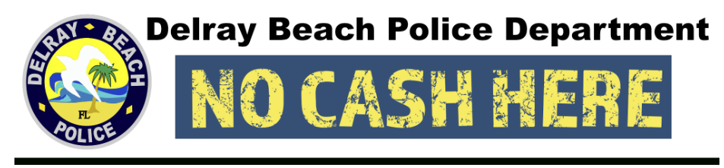

**PROGRAM ENROLLMENT FORM**

**Dear business owner,**

Thank you for participating in the Delray Beach Police Department’s “No Cash Here” program. The goal of the program is to reduce the risk of burglary to your property by letting would-be criminals know you keep no cash on the premises after business hours. At the close of business each day, remove the money from your register and leave the empty cash drawer out in plain view. Affix a “*No Cash Here*” decal to any exterior public access door or front window to your business, particularly where cash registers are located. Please complete this enrollment form and make sure to update the police department if contact information should change, so we know whom to call in the event of an incident at your business. Thank you for helping us keep our community safe and crime-free. **Sincerely, DBPD**

Date: _____________________________________

Business Name: _________________________________________________________________________

Business Days/Hours of Operation: __________________________________________________________

Address: _______________________________________________________________________________

________________________________________________________________________________

Business Phone(s): (______)______________________ /(______)_________________________________

Owner/Manager Name (Printed): ___________________________________________________________

E-mail Address: _________________________________________________________________________

CCTV - Video Surveillance System Present: YES or NO

CCTV Locations (Internal/External): _______________________________________________________

_______________________________________________________

Security Alarm System Present: YES or NO

Emergency Callout Name & Number(s): _____________________________________________________

_____________________________________________________