**PUBLIC NOTICE**

**RE:** **Variance requests for the property located at 300 Sandpiper Lane.**

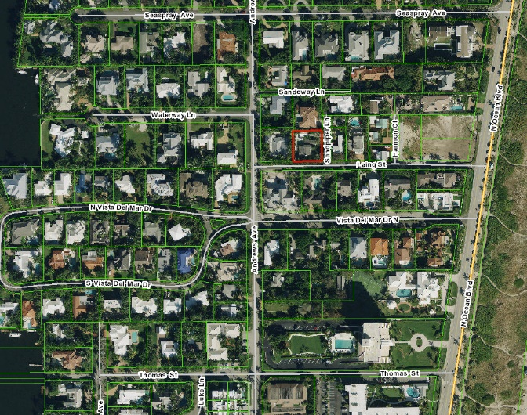Pursuant to Section 2.4.2(B)(1)(f)of the Land Development Regulations (LDR) of the City of Delray Beach, this notice is to inform that the **Board of Adjustment** of the City of Delray Beach, Florida, will conduct a **VIRTUAL PUBLIC HEARING** on **Thursday, November 5, 2020 at 5:01 pm** to consider variance requests for the property located at **300 Sandpiper Lane** (see map below)**.** Pursuant to LDR Section 4.3.4(K), a minimum rear setback of 12 feet is required for properties within the R-1-AAA (Single-Family Residential) zoning district. The request is to reduce the required rear setback by 8 feet thereby establishing a 5-foot rear setback associated with the construction of an addition to an existing single-family home. The property measures approximately 0.22 acres.

The proposed variance request may be reviewed online at <https://www.delraybeachfl.gov/government/city-departments/city-clerk/public-notices>. If you would like further information as to how the subject request may affect your property, please contact Elizabeth Eassa, AICP, Senior Planner, at (561) 243-7325***,*** or via email at [EassaE@mydelraybeach.com](mailto:EassaE@mydelraybeach.com), at the Development Services Department, City Hall, 100 NW 1st Avenue, Delray Beach, Florida 33444.

All interested parties are invited to attend and submit public comments upon the proposed action or submit their comments in writing on or before the date of the hearing to the Development Services Department. Please be advised that if the action taken on this request is appealed, the appellant may need to ensure that a verbatim record includes the testimony and evidence upon which the appeal is to be based. The City does not provide nor prepare such record pursuant to F.S. 286.0105. Pursuant to 2.2.4(D)(8) All decisions of the Board of Adjustment are final. Any person or persons, or any Board, Taxpayer, Department, Board, or Bureau of the City may aggrieve any decision of the Board of Adjustment and may seek review of such decision in the Circuit Court of Palm Beach County.