**PUBLIC NOTICE**

**RE:** **Variance requests for the property located at 311 SE 3rd Street.**

Pursuant to Section 2.4.2(B)(1)(f)of the Land Development Regulations (LDR) of the City of Delray Beach, this notice is to inform that the **Board of Adjustment** (BOA) of the City of Delray Beach, Florida, will conduct a **PUBLIC HEARING** on **Thursday, November 5, 2020 at 5:01 pm** to consider variance requests for the property located at **311 SE 3rd Street** (see map inset)**.** The property owner**, James Sandwick,** is seeking the variance requests for the new construction of a single-family residence and swimming pool. The property measures approximately 0.0845 acres. The proposed request was previously noticed for the BOA meeting of August 6, 2020; the Board moved to continue the request to the following meeting**.**

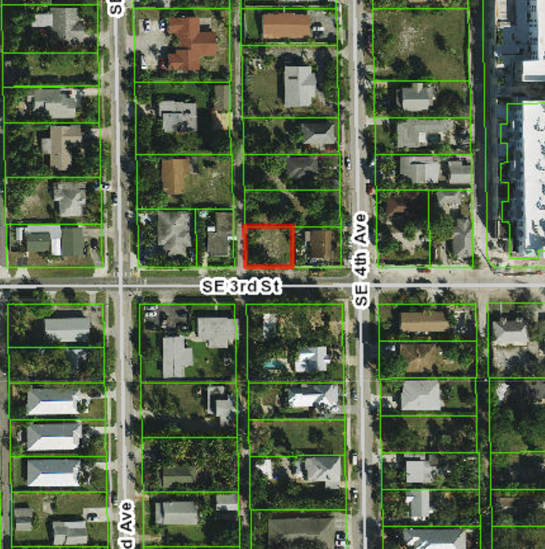

Pursuant to LDR Section 4.3.4(K), a minimum side-street setback of 15 feet is required for properties within the R-1-A (Single-Family Residential) zoning district. The request is to reduce the required side street (west) setback by 7.5 feet, thereby establishing a 7.5-foot side street setback. Pursuant to LDR Section 4.6.15(G), swimming pools shall not extend into the front setback area as noted in Section 4.3.4(K). The proposal includes a request to allow a swimming pool in the front setback, situated 11’ 3 ½” feet from the front (south) property line.

The proposed variance request may be reviewed online at <https://www.delraybeachfl.gov/government/city-departments/city-clerk/public-notices>. If you would like further information as to how the subject request may affect your property, please contact Rachel Falcone, Planner, at (561) 330-6052***,*** or via email at [FalconeR@mydelraybeach.com](mailto:alvarez@mydelraybeach.com), at the Development Services Department, City Hall, 100 NW 1st Avenue, Delray Beach, Florida 33444.

All interested parties are invited to attend and submit public comments upon the proposed action or submit their comments in writing on or before the date of the hearing to the Development Services Department. Please be advised that if the action taken on this request is appealed, the appellant may need to ensure that a verbatim record includes the testimony and evidence upon which the appeal is to be based. The City does not provide nor prepare such record pursuant to F.S. 286.0105. Pursuant to 2.2.4(D)(8) All decisions of the Board of Adjustment are final. Any person or persons, or any Board, Taxpayer, Department, Board, or Bureau of the City may aggrieve any decision of the Board of Adjustment and may seek review of such decision in the Circuit Court of Palm Beach County.

City of Delray Beach

Development Services Department