**PUBLIC NOTICE**

**RE:** **Variance requests for the property located at 220 South Ocean Boulevard.**

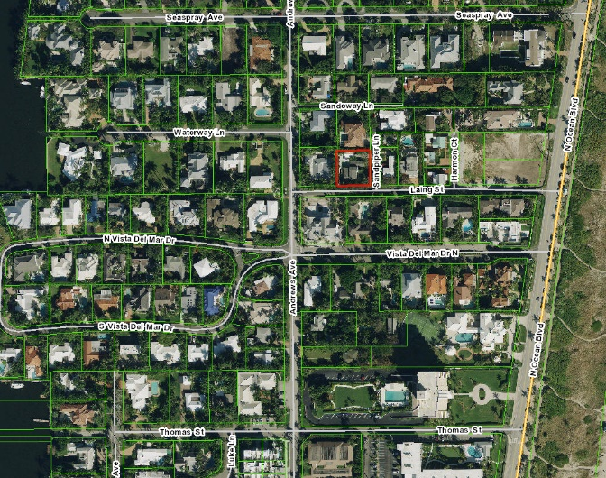Pursuant to Section 2.4.2(B)(1)(f)of the Land Development Regulations (LDR) of the City of Delray Beach, this notice is to inform that the **Board of Adjustment** of the City of Delray Beach, Florida, will conduct a **VIRTUAL PUBLIC HEARING** on Thursday, November 5, 2020 at 5:01 pm to consider a variance request from Land Development Regulations (LDR) Sections 4.3.4(K) and 4.6.15(1) to allow a swimming pool to encroach 11.5 feet into the front setback area for the property located at **220 South Ocean Boulevard** (see map below). The Variance request is to allow a swimming pool to encroach 11.5 feet within the front setback area. Pursuant to LDR Section 4.6.15(G), swimming pools are allowed within the sides and rear setback areas only, they are not permitted in the front setback area. Per LDR Section 4.3.4(K) Single-Family Detached Dwellings within the RM Zoning District are required to provide a minimum front setback of 25 feet.

The proposed variance request may be reviewed online at <https://www.delraybeachfl.gov/government/city-departments/city-clerk/public-notices>. If you would like further information as to how the subject request may affect your property, please contact Elizabeth Eassa, AICP, Senior Planner, at (561) 243-7325***,*** or via email at [EassaE@mydelraybeach.com](mailto:EassaE@mydelraybeach.com), at the Development Services Department, City Hall, 100 NW 1st Avenue, Delray Beach, Florida 33444.

All interested parties are invited to attend and submit public comments upon the proposed action or submit their comments in writing on or before the date of the hearing to the Development Services Department. Please be advised that if the action taken on this request is appealed, the appellant may need to ensure that a verbatim record includes the testimony and evidence upon which the appeal is to be based. The City does not provide nor prepare such record pursuant to F.S. 286.0105. Pursuant to 2.2.4(D)(8) All decisions of the Board of Adjustment are final. Any person or persons, or any Board, Taxpayer, Department, Board, or Bureau of the City may aggrieve any decision of the Board of Adjustment and may seek review of such decision in the Circuit Court of Palm Beach County.