**NOTICE OF PUBLIC HEARING**

**CONDITIONAL USE**

Pursuant to Section 2.4.2(B)(1)(e) of the Land Development Regulations of the City of Delray Beach, Florida, you are hereby notified of a Conditional Use Permit request to establish a Family Community Residence at 727 Place Tavant for 6 residents. A family community residence is a relatively permanent living arrangement for four to ten unrelated people with disabilities with no limit on how long a resident may live in the home. The length of tenancy is measured in years.

The PLANNING AND ZONING BOARD, acting as the Local Planning Agency, will hold a Public Hearing on the Conditional Use Permit request on January 27, 2020 at 6 pm, (or as soon thereafter as may be heard), in the Commission Chambers at City Hall, 100 NW 1st Avenue, Delray Beach, Florida, for the purpose of receiving public comment. If you would like further information with regard to how this proposed action may affect your property, or if you would like to review the plans for this request, please contact Kent Walia, Senior Planner, Development Services Department located at 100 NW 1st Avenue, Delray Beach, Florida 33444, e-mail [waliak@mydelraybeach.com](mailto:waliak@mydelraybeach.com), or by phone at 561-243-7365, between the hours of 8:00 A.M. and 5:00 P.M., Monday through Friday, excluding holidays.

All interested parties are invited to attend the public hearing and comment on the proposed Conditional Use Request, or submit their comments in writing on or before the date of the hearing, to the Development Services Department/Planning and Zoning Division. Please be advised that if a person decides to appeal any decision made by the Planning and Zoning Board with respect to any matter considered at this hearing, such person will need a record of these proceedings, and for this purpose such person may need to ensure that a verbatim record of the proceedings is made, which record includes the testimony and evidence upon which the appeal is based. The City does not provide or prepare such record pursuant to F.S. 286.0105.

City of Delray Beach

Development Services Department/Planning and Zoning Division

Date Posted: **January 17, 2020**

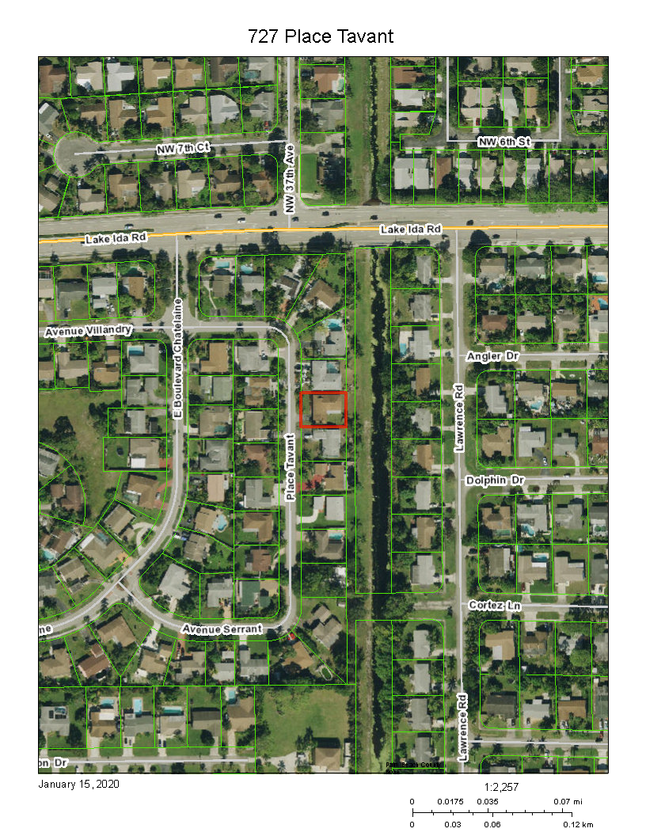

C-15 Canal