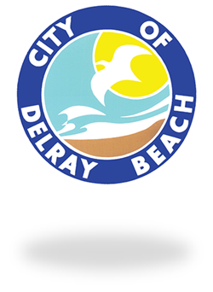

**PUBLIC NOTICE**

**THE PUBLIC IS ADVISED that the STEERING COMMITTEE FOR THE COMPREHENSIVE PLAN UPDATE will meet on Wednesday, May 16, 2018, from 6:00 p.m. to 9:00 p.m. in the First Floor Conference Room at City Hall, 100 NW 1st Avenue, Delray Beach, Florida, 33444 and two (2) or more members of the City Commissions may be in attendance.**

Katerri Johnson CMC

City Clerk

**Post: May 7, 2018**

**The City shall furnish appropriate auxiliary aids and services where necessary to afford an individual with a disability an equal opportunity to participate in and enjoy the benefits of a service, program, or activity conducted by the City. Please contact the City Manager at (561) 243-7015 24 hours prior to the program or activity in order for the City to reasonably accommodate your request.**