**PUBLIC NOTICE**

**RE: CENTRAL BUSINESS DISTRICT STREETSCAPE WAIVER, FRONT SETBACK WAIVER, AND CIVIC OPEN SPACE WAIVER REQUEST FOR THE MAXWELL PROJECTLOCATED ON 306 NE 2ND STREET**

This notice is being provided as your property is located within 500 feet of the subject property.

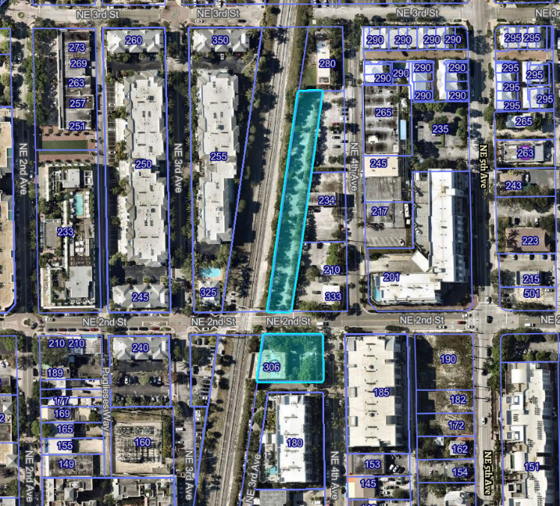Pursuant to the Land Development Regulations (LDR) of the City of Delray Beach, you are hereby notified that the **City Commission**, will conduct a **Public Hearing** for the purpose of accepting public testimony regarding three Waivers requests associated with a Level 4 Site Plan for a mixed-use development. The waivers are as follows:

1. Waiver to reduce the streetscape dimension from the required 15 feet to 11 feet and 2 inches,
2. Waiver to reduce the front setback requirement on the corner of NE 4th Street and Railroad Street from the required 10 feet to 0 feet, and
3. A picture containing text, clipart

   Description automatically generatedWaiver to allow the square footage within the required front setback to be calculated towards the required Civic Open Space square footage.

The Public Hearing will be held on **TUESDAY, October 1, 2024, at 6:00 PM**, in the Commission Chambers at City Hall, 100 N.W. 1st Avenue, Delray Beach, Florida.

If you would like further information as to how the request may affect your property, please contact the Development Services Department at City Hall, 100 NW 1st Avenue, Delray Beach, Florida 33444, at (561) 243-7325 or [howalda@mydelraybeach.com](mailto:howalda@mydelraybeach.com) or [rodriguess@mydelraybeach.com](mailto:rodriguess@mydelraybeach.com).

Members of the public wishing to view City Commission meetings may attend in person in the City Commission Chambers at 100 NW 1st Avenue, Delray Beach, FL 33444 or view the meeting through the City’s website at <https://www.delraybeachfl.gov/i-want-to/watch/city-meetings>, where it will be live-streamed for the public. Any member of the public wishing to comment publicly on any matter, including public comment or public hearing items, may comment in-person during the presentation of the item, or submit their comments in writing to the Development Services Department by e-mail to [pzmail@mydelraybeach.com](mailto:pzmail@mydelraybeach.com) or by regular mail at 100 NW 1st Avenue, Delray Beach, FL 33444.

PLEASE BE ADVISED THAT IF A PERSON DECIDES TO APPEAL ANY DECISION MADE BY THE CITY COMMISSION WITH RESPECT TO ANY MATTER CONSIDERED AT THIS HEARING, SUCH PERSON WILL NEED A RECORD OF THE PROCEEDINGS, AND FOR THIS PURPOSE SUCH PERSON MAY NEED TO ENSURE THAT A VERBATIM RECORD OF THE PROCEEDINGS IS MADE, WHICH RECORD INCLUDES THE TESTIMONY AND EVIDENCE UPON WHICH THE APPEAL IS BASED. THE CITY DOES NOT PROVIDE OR PREPARE SUCH RECORD PURSUANT TO F.S. 286.0105.A picture containing text, clipart
