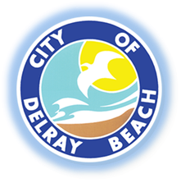

PUBLIC NOTICE

THE PUBLIC IS ADVISED the City and the Service Employees International Union (SEIU) will be bargaining Wednesday, September 18, 2024, from 2:30 p.m. to 5:00 p.m. at City Hall located at 100 N.W. 1st Avenue, Delray Beach, FL 33444 in the City Commission Chambers.

Alexis Givings, CMC
Acting City Clerk

Post Date: 4/11/23

The City shall furnish appropriate auxiliary aids and services where necessary to afford an individual with a disability an equal opportunity to participate in and enjoy the benefits of a service, program, or activity conducted by the City. Please contact Denis Placide at (561) 243-7346 24 hours prior to the program or activity in order for the City to reasonably accommodate your request.

