**PUBLIC NOTICE**

**RE: Voluntary Annexation (File No. 2023-109), Land Use Map Amendment (File No. 2023-108), and Rezoning (File No. 2023-107) Request for 4594 133 Road South**

Pursuant to the Land Development Regulations of the City of Delray Beach, you are hereby notified that the **CITY COMMISSION** will conduct a **PUBLIC HEARING** on **TUESDAY NOVEMBER 7, 2023 at** **5:01 PM** to consider and make a recommendation to the City Commission on a privately-initiated request for Voluntary Annexation (Ordinance 21-23), Land Use Map Amendment (LUMA) (Ordinance No. 22-23), and a rezoning request (Ordinance No. 23-23) for the 5.08 acre property located at 4594 133 Road South (map below).

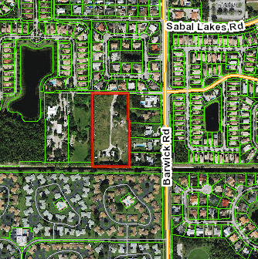

The applicant is requesting a Voluntary Annexation from unincorporated Palm Beach County; a change in land use designation from Palm Beach County Medium Residential (MR-5) to the City of Delray Beach Low Density (LD) land use designation; and a rezoning from Palm Beach County Agriculture Residential (AR) to City of Delray Beach Single Family Residential (R-1-A) (see maps on the following page). The applicant indicates its intent to develop the property as a single-family neighborhood, which requires a major plat (reviewed separately).

If you would like further information on the request, please contact the Development Services Department at City Hall, 100 NW 1st Avenue, Delray Beach, Florida 33444, at (561) 243-6236 or [rodriguezg@mydelraybeach.com](mailto:rodriguezg@mydelraybeach.com).

Members of the public wishing to view Planning and Zoning Board meetings may attend in person in the City Commission Chambers at 100 NW 1st Avenue, Delray Beach, FL 33444 or view the meeting through the City’s website at <https://www.delraybeachfl.gov/i-want-to/watch/city-meetings>, where it will be live-streamed for the public. Any member of the public wishing to comment publicly on any matter, including public comment or public hearing items, may comment in-person during the presentation of the item, or submit their comments in writing to the Development Services Department by e-mail to [pzmail@mydelraybeach.com](mailto:pzmail@mydelraybeach.com) or by regular mail at 100 NW 1st Avenue, Delray Beach, FL 33444.

PLEASE BE ADVISED THAT IF A PERSON DECIDES TO APPEAL ANY DECISION MADE BY THE PLANNING AND ZONING BOARD WITH RESPECT TO ANY MATTER CONSIDERED AT THIS HEARING, SUCH PERSON WILL NEED A RECORD OF THE PROCEEDINGS, AND FOR THIS PURPOSE SUCH PERSON MAY NEED TO ENSURE THAT A VERBATIM RECORD OF THE PROCEEDINGS IS MADE, WHICH RECORD INCLUDES THE TESTIMONY AND EVIDENCE UPON WHICH THE APPEAL IS BASED. THE CITY DOES NOT PROVIDE OR PREPARE SUCH RECORD PURSUANT TO F.S. 286.0105.

City of Delray Beach

Planning and Zoning Department

Date Posted October 30, 2023

|  |  |
| --- | --- |
|  |  |
|  |  |