File #2022-044

# NOTICE OF PUBLIC HEARING

**VARIANCE**

Pursuant to the Land Development Regulations (LDR) of the City of Delray Beach, you are hereby notified that the **Board of Adjustment** will conduct a **Public Hearing at 5:01 PM on September 7, 2023,** (or as soon thereafter as may be heard), in the City Commission Chambersat City Hall, 100 NW 1st Avenue, Delray Beach, Florida to consider two variance requests from the requirements of the Land Development Regulations (LDR) for the property located at **809 NW 2nd Street**.

The variance requests, associated with the new construction of a single-family residence, are as follows:

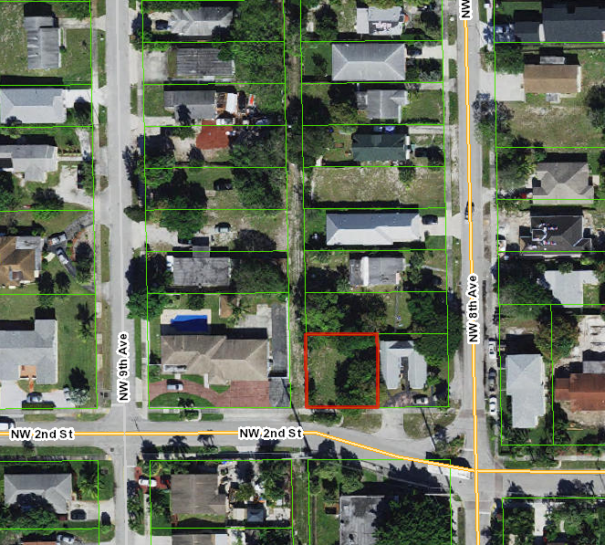

* LDR Section 4.3.4(K), Development Standards Matrix: Reduce the side-street (west) setback to 13 feet, whereas a minimum of 15 feet is required.
* LDR Section 4.6.15(G)(1), Yard Encroachments: Allow a swimming pool to be placed within the front (south) setback, 15 feet from the property line, whereas a minimum of 25 feet is required.

If you would like further information as to how the request may affect your property, please contact the Development Services Department at (561) 243-7040, by e-mail to pzmail@mydelraybeach.com or by regular mail at 100 NW 1st Avenue, Delray Beach, FL 33444.

Members of the public wishing to participate may attend in person in the City Commission Chambers at 100 NW 1st Avenue, Delray Beach, FL 33444 or view the meeting through the City’s website, https://www.delraybeachfl.gov/i-want-to/watch/city-meetings, where the meeting will be live streamed for the public. Any member of the public wishing to comment publicly on any matter, including public comment or public hearing items, may comment in-person during the presentation of the item, or submit their comments in writing to the Development Services Department by email to pzmail@mydelraybeach.com or by regular mail at 100 NW 1st Avenue, Delray Beach, FL 33444.

Please be advised that if a person decides to appeal any decision made by the Board of Adjustment with respect to any matter considered at this meeting or hearing, such person will need a record of the proceedings, and for this purpose such person may need to ensure that a verbatim record of the proceedings is made, which record includes the testimony and evidence upon which the appeal is based. The City does not provide or prepare such record pursuant to F.S. 286.0105.