**PUBLIC NOTICE**

**RE: Rezoning REQUEST FOR 620 Lake IDA (PCN # 12-43-46-08-21-005)**

Pursuant to the Land Development Regulations (LDR) of the City of Delray Beach, you are hereby notified that the **CITY COMMISSION** will conduct a **Public Hearing** for the purpose of accepting public testimony regarding a privately initiated request for a rezoning request (Ordinance No. 09-22) for the +/-0.183-acre property located at 620 Lake Ida Road.

The Public Hearing will be held on **TUESDAY, June 7, 2022, at** **4:00 PM**, or as soon thereafter, in the Commission Chambers at City Hall, 100 N.W. 1st Avenue, Delray Beach, Florida. At this meeting, the City Commission will consider the following ordinance:

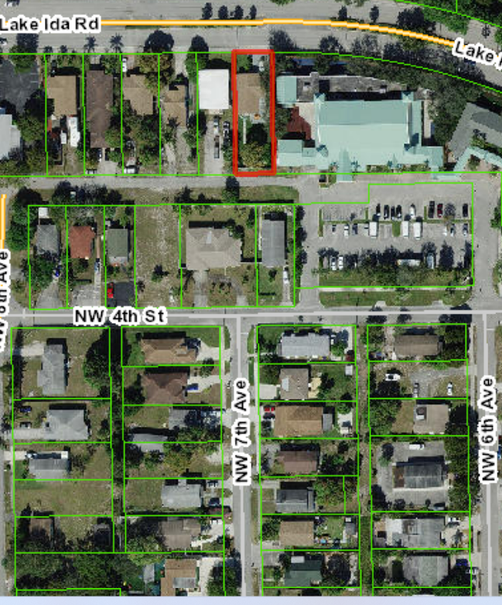

**Rezoning, Ordinance No. 09-22**

Existing Zoning District: R-1-A (Single Family Residential)

Proposed Zoning District: CF (Community Facilities)

Additional information on the request can be found on the “Development Projects” page under the Development Services Department at [www.delraybeachfl.gov](http://www.delraybeachfl.gov). If you would like further information as to how the request may affect your property, please contact the Development Services Department at City Hall, 100 NW 1st Avenue, Delray Beach, Florida 33444, at (561) 243-7040, Ext. 7138 or [buce@mydelraybeach.com](mailto:buce@mydelraybeach.com).

Members of the public wishing to view City Commission meetings may attend in person in the City Commission Chambers at 100 NW 1st Avenue, Delray Beach, FL 33444 or view the meeting through the City’s website at <https://www.delraybeachfl.gov/i-want-to/watch/city-meetings>, where it will be live-streamed for the public. Any member of the public wishing to comment publicly on any matter, including public comment or public hearing items, may comment in-person during the presentation of the item, or submit their comments in writing to the Development Services Department by e-mail to [pzmail@mydelraybeach.com](mailto:pzmail@mydelraybeach.com) or by regular mail at 100 NW 1st Avenue, Delray Beach, FL 33444.

PLEASE BE ADVISED THAT IF A PERSON DECIDES TO APPEAL ANY DECISION MADE BY THE CITY COMMISSION WITH RESPECT TO ANY MATTER CONSIDERED AT THIS HEARING, SUCH PERSON WILL NEED A RECORD OF THE PROCEEDINGS, AND FOR THIS PURPOSE SUCH PERSON MAY NEED TO ENSURE THAT A VERBATIM RECORD OF THE PROCEEDINGS IS MADE, WHICH RECORD INCLUDES THE TESTIMONY AND EVIDENCE UPON WHICH THE APPEAL IS BASED. THE CITY DOES NOT PROVIDE OR PREPARE SUCH RECORD PURSUANT TO F.S. 286.0105.

City of Delray Beach

Planning and Zoning Department

Date Posted: May 27, 2022

